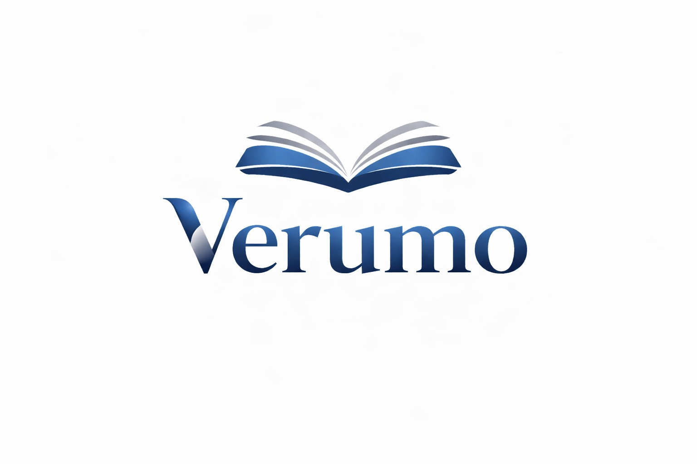

Bookkeeping documents for your first meeting
These documents help us understand your bookkeeping situation.
Gather only the documents you have that are relevant. This checklist collects information; it does not provide a legal or tax assessment.

Business overview
☐ Brief description of your activity and your questions
☐ Latest available annual accounts or current reports
☐ Existing chart of accounts and bookkeeping software used

Records and payments
☐ Sales invoices and outstanding customer balances
☐ Supplier invoices and outstanding payables
☐ Bank and card statements for the agreed period

Other records as needed
☐ Cash book and receipts if you use cash
☐ Existing VAT returns and correspondence, if available
☐ Payroll summaries and social insurance records if you have employees
☐ List of available fixed assets and business loans or lease agreements

Next steps
Tick the documents available. Note your questions and arrange a meeting with Verumo. We can identify missing documents together.
Verumo GmbH · Kirchstrasse 24 · 3097 Liebefeld
info@verumo.ch · +41 31 512 99 14
As at 19.10.2026

