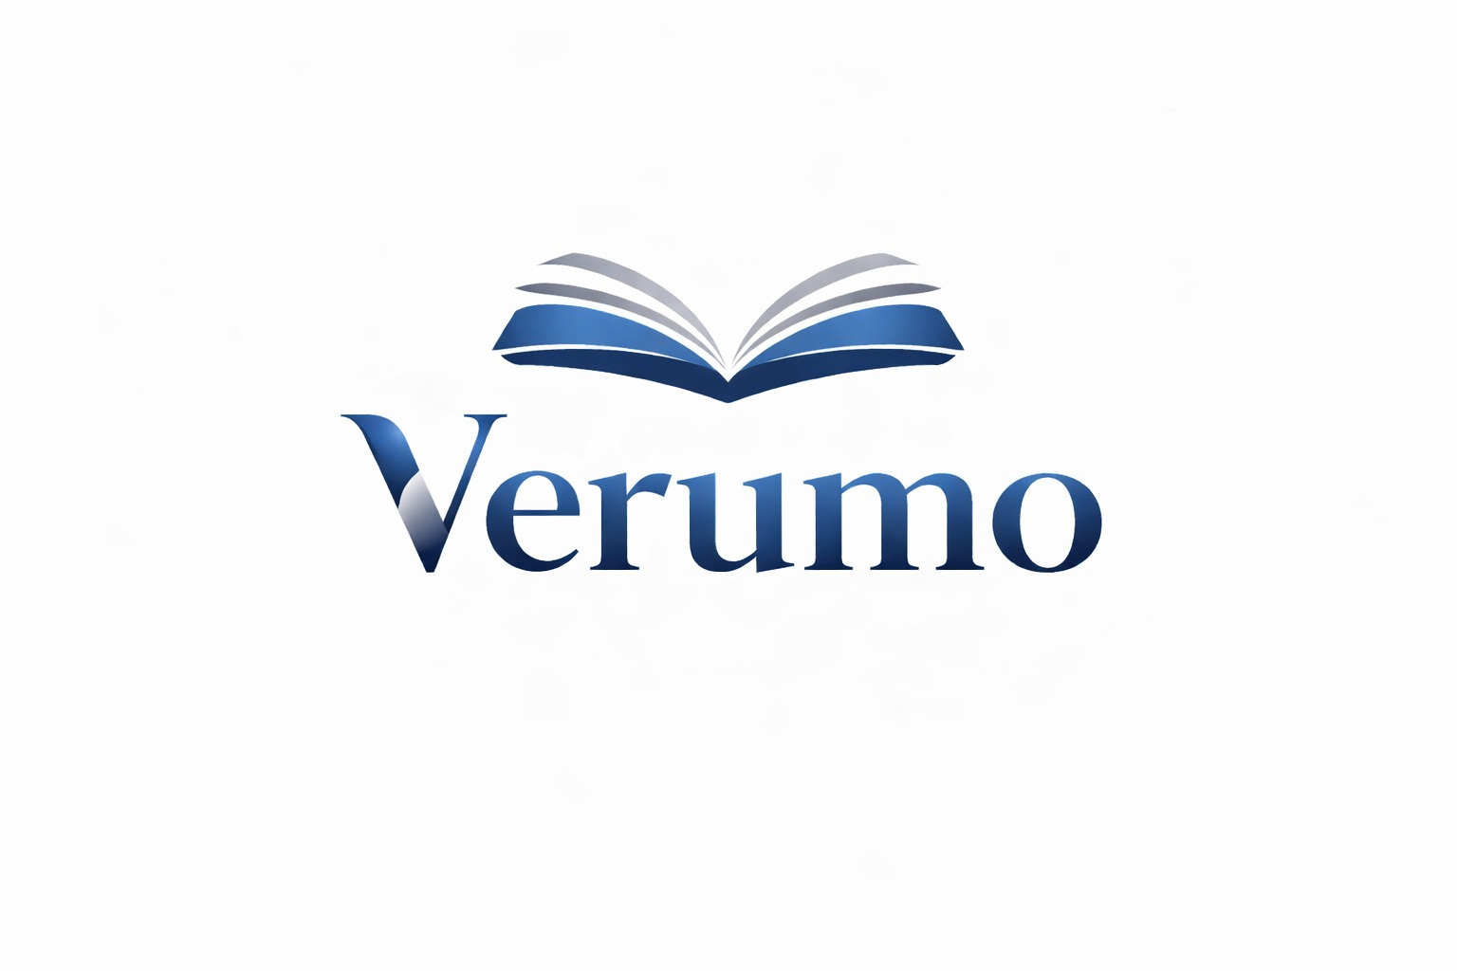

Property records for your first meeting
Available property records help us discuss your needs effectively.
Gather only the documents you have that are relevant. This checklist collects information; it does not provide a legal or tax assessment.

Property and purpose
☐ Property address, type and brief description of your needs
☐ Available land register extract or proof of ownership
☐ Available plans, floor areas and property description

Use and management
☐ Existing tenancy agreements and current rent schedule if let
☐ Latest available service charge or property management statements
☐ Existing management and service agreements

Costs and other records
☐ Records of completed or planned maintenance work
☐ Available financing overview and ongoing property costs
☐ For condominium ownership, available regulations and recent meeting minutes
☐ List of known damage, open questions and your objectives

Next steps
Tick the documents available. Note your questions and arrange a meeting with Verumo. We can identify missing documents together.
Verumo GmbH · Kirchstrasse 24 · 3097 Liebefeld
info@verumo.ch · +41 31 512 99 14
As at 19.10.2026

